**NAME : MUHAMMAD BIN AKHTAR**

**ROLL NO.: 467463**

**ME-15 Sec-B**

**FOP-08 HOME TASKS**

**TASK-1**

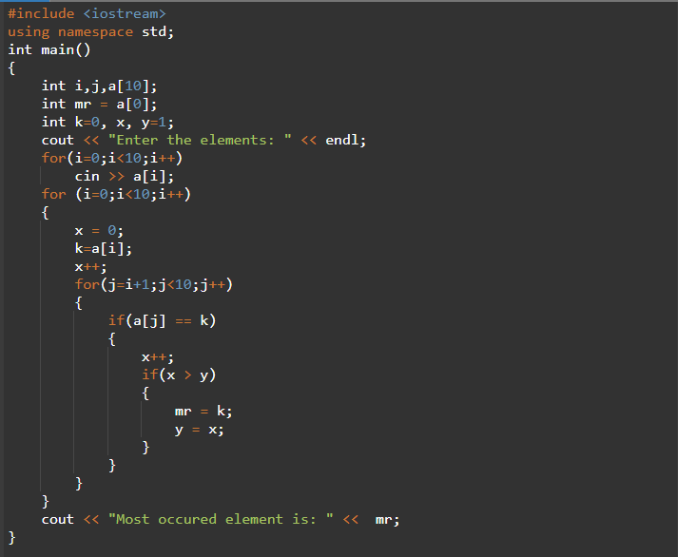

**OUTPUT**



**TASK-2**

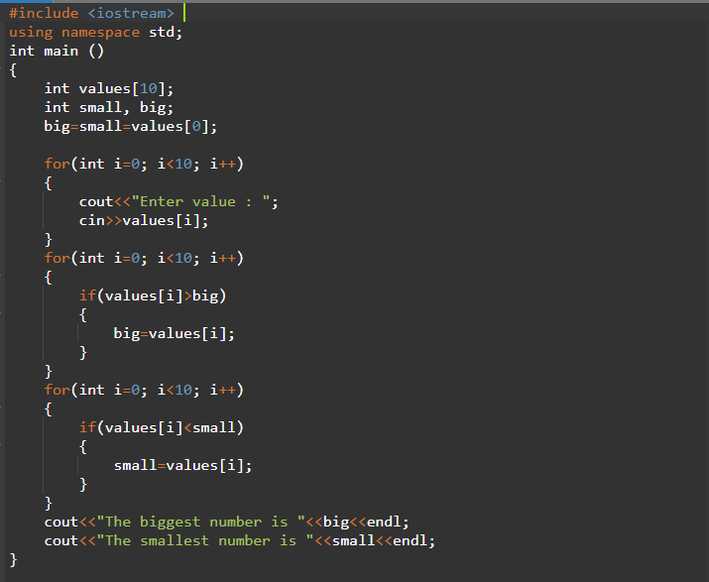

**OUTPUT**



**TASK-3**

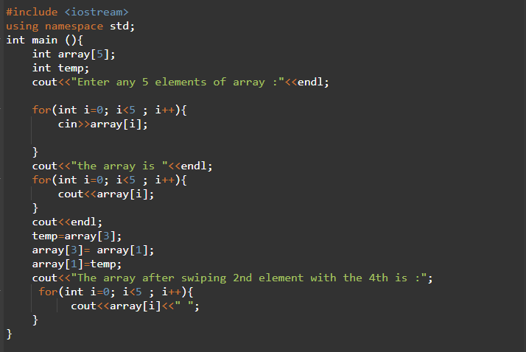

**OUTPUT**

